2023 Logo Crest and Souvenirs

Logo Theme Crest - $5 each
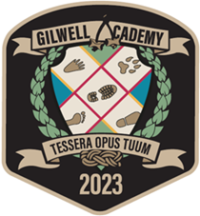

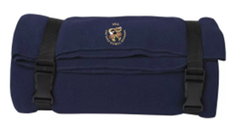
Navy Blanket - $38 each
Product Features: 14-oz, 100% polyester
Tonal cover stich edge finish
Carrying strap with buckle
50" long and 60" wide

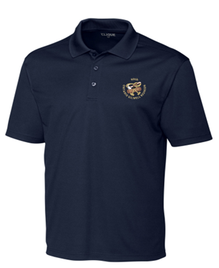
Navy Golf Shirts - $35 each
Unisex Sizes - XS to 4XL
Size Chart:
XS - 32-34; S -35-38
M - 39-41; L - 42-45
XL - 46-49; 2XL - 50-52; 3XL - 53-56; 4XL - 57-60
Features: Dyed to match buttons
Three button plackets
Cationic dues for superior brightness
and excellent colorfastness
100 % polyester interlock
Moisture-wicking and UV protection

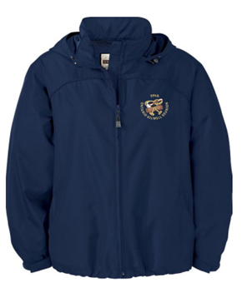
Navy Windbreakers - $60 each
Unisex sizes XS to 4 XL
Size Chart:
XS – 34-36; S - 36-38
M - 39-41; L - 42-44
XL - 45-48; 2XL - 49-52
3XL - 53-56; 4XL - 57-60
Features: Roll away hood & vented back yoke
adjustable cuff with tabs
adjustable shock cord at hood & hem

